36.21: a) If the slits are very narrow, then the first maximum is at
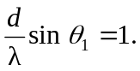
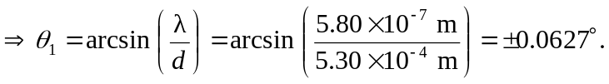
Also, the second maximum is at
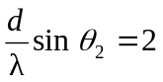
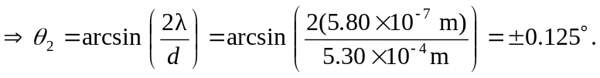
b) 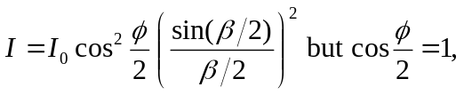since we are at the 2 slit maximum. So
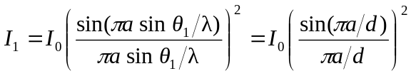
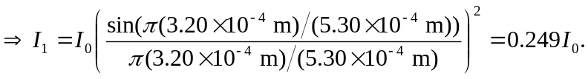
And

